National Institute of Technology Calicut

**Office of Dean (R & C)**

**Funding Scheme for UG/PG Students to Carry Out Innovative Projects Application Format - 2021**

|  |  |  |  |  |
| --- | --- | --- | --- | --- |
|  | Name of the applicants |  |  |  |
|  | * Maximum 4 students for B. Tech/B. Arch students * Individual projects for PG | Roll No | Branch of study | Mobile Number & email id |
|  | students |  |  |  |
|  |  |  |  | 9441120187 |
|  | POOLA ROHITH | B180712ME | MECHANICAL |  |
|  |  |  |  | [rohith18p@gmail.com](mailto:rohith18p@gmail.com) |
| 1 | AKONDI SAI MANOJ | B180161ME | MECHANICAL | 6303364524  manojakondi25@gmail. |
|  |  |  |  | com |
|  |  |  |  | 9441214164 |
|  | MAMIDI THEJONATH | B180129ME | MECHANICAL |  |
|  |  |  |  | [tejonathg21@gmail.com](mailto:tejonathg21@gmail.com) |
|  |  |  |  | 9381222285 |
|  | KURAGANTI VEDANTHAM | B180473ME | MECHANICAL | vedantham_b180473me |
|  |  |  |  | @nitc.ac.in |
| 2 | Name of the project leader (one of the students shall be the project leader) | POOLA ROHITH | | |
| Mobile Number & email id | 9441120187  [rohith18p@gmail.com](mailto:rohith18p@gmail.com) | | |
| Name of FA/PC | Dr. Ashesh Saha | | |
| 3 | Title of the project proposal | Robot Based Automation for Vertical Farming | | |

|  |  |  |  |
| --- | --- | --- | --- |
| 4 | Expected outcome of the project- point wise  (details shall be given in attached proposal) | * Fully automated robotic system for vertical farming. * Automation of planting, watering, inspection, conditioning and harvesting of crops. * Patents for the innovation or publishing of SCI Journal. | |
| 5 | Deliverables - research paper in SCI journal or patent/copyright of novel idea to be filed or a novel product to be commercialized or technology transfer | Patents / Research paper in SCI journal | |
| 6 | Total fund requested (Rs) | 90000 | |
| 7 | Name of guide(s) | Students from different depts. or doing interdisciplinary projects can provide guides from appropriate discipline. | |
| Name of guide(s)/co-guide | Dept. | Mobile No & email id |
| Dr. A P Sudheer | Mechanical | 9961450987  [apsudheer@nitc.ac.in](mailto:apsudheer@nitc.ac.in) |
| Dr. K Sekar | Mechanical | 9746562695  [sekar@nitc.ac.in](mailto:sekar@nitc.ac.in) |
|  |  |  |
| 8 | Significance of the proposed project (details shall be given in attached proposal) | Implementation of vertical farming and Hydroponics which are the future of agriculture. Automating the Vertical farming by robot-based system and artificial intelligence has wide impact and greater advantages and flexibilities than the conventional farming. | |

|  |  |  |  |
| --- | --- | --- | --- |
| 9 | Expected time required for completion of project  (attach semester wise targets) | 10 months (until  31-MAR-2022) | SEVENTH SEMESTER   * Finalizing the project details and idea. * Complete design and development of CAD model. * Simulation and analysis EIGHTH SEMESTER * Prototype fabrication and assembly. * Complete control and automation. |
| 10 | Split-up of Budget in Rs | Stage 1 (first | Stage 2 (remaining period) |
|  |  | six months) |  |
|  | Software packages |  | - |
|  |  | - |  |
|  | Minor equipment * |  | - |
|  |  | - |  |
|  | Consumables |  | 17000 |
|  |  | - |  |
|  | Contingencies |  | 20000 |
|  |  | - |  |
|  | Others if any |  |  |
|  | Mechanical Components | - | 10000 |
|  | Electronic components |  | 53000 |
|  |  | - |  |
|  | Total |  | 100000 |

*(Give details of all the students sequentially in the case of a group. For a group with students from different departments, recommendation from the concerned head of department of all students shall be obtained)*

* Name & Signature of the applicant(s):
  1. POOLA ROHITH



* 1. AKONDI SAI MANOJ

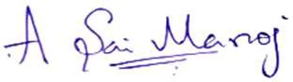

* 1. MAMIDI TEJONATH

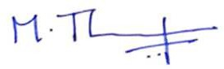

* 1. KURAGANTI VEDANTHAM

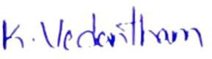

*  Name & Signature of project guide(s): I/we have gone through the proposal and guidelines.

GUIDE:

Dr. SUDHEER A. P.

Assistant Professor Mechanical department

CO-GUIDE:

Dr. K Sekar Assistant Professor

Mechanical department

27/05/2021



* Recommendation from the Head of the Department:

Dr. JOSE MATHEW

Professor (HAG) Mechanical Department

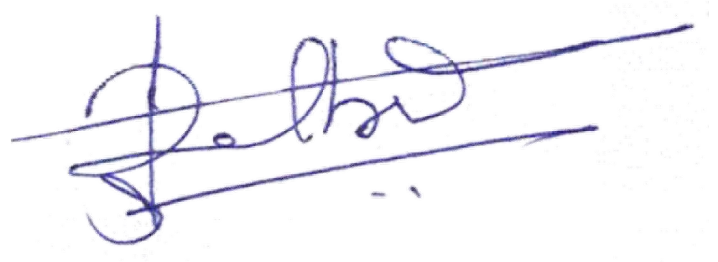13-6-21

**Notes:**

1. A detailed proposal must be attached along with this application giving the objectives, significance of the work, expected outcomes, literature review (including patent search), methodology and work plan, budget with justifications and any other relevant information in support of the proposal
2. The aim of this funding scheme is to promote research culture in UG students and accordingly through the research, they shall develop an innovative product. This can also lead to commercialization and start-up or patenting the novelty. Minimum an SCI journal publication shall come from the project. The financial assistance will be provided to carry out the related activities (to meet the expenses related to fabrication/assembly charges, consumables and contingency). * minor equipment /tools may be permitted, if very specific and essential. No major equipment is permitted under this scheme.

Revised Budget list (after the meeting):

|  |  |  |
| --- | --- | --- |
| **Items required** | **Amount** | **Justification based on the outcome expected** |
| G.I pipes | 3000 | Table & lift frame |
| Aluminum extrusions & plates | 5000 | Table & Manipulator |
| Wood floor | 1000 | Table base |
| PVC parts | 1000 | Planting environment & Water storage |
| Couplings, Leadscrews | 2000 | Manipulator & Lift |
| Hydroponics | 10000 | Nutrient solution |
| Motors | 24000 | Manipulator & Lift |
| Motor drivers | 10000 | For motors |
| PCB | 4000 | Circuits |
| Camera | 5000 | Vision & Inspection |
| Jetson Nano | 10000 | Computation |
| Batteries | 5000 | Power source |
| Other consumables | 5000 | Fabrication |
| Contingencies | 5000 | Precaution for actuators & sensors |
| **TOTAL** | **90000** |  |